Algebra 1: Unit 7, Lesson 6

- The Gianna was factoring the trinomial $15n^{2}-4n-32$ using the factoring by grouping strategy. Her partial work is shown.
$15n^{2}-4n-32$
$15n^{2}-24n+20n-32$
$$\left(15n^{2}-24n\right)+(20n-32)$$
________________________
$$(3n+4)(5n-8)$$What is the step that would complete Gianna’s work?
$$3n\left(5n-8\right)+4(5n-8)$$

- Penny rearranged the terms of a polynomial two different ways in order to factor by grouping.
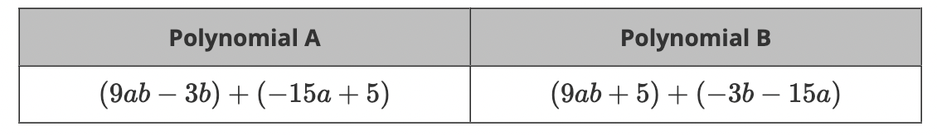
Penny determined that only one of the rearranged ways would work to factor by grouping and reveal $(3a-1)$ as a common factor between the two groups.
___________________ is not grouped correctly to be able to factor by grouping because once the greatest common factor is factored out of the two groups, no common factor is revealed.
Polynomial B

- A trinomial is shown in the form of $ax^{2}+bx+c$
$$(x-5)(4x+1)$$
$$4x^{2}-19x-5$$The expression can then be grouped and factored as________________________.

